

Machine Learning Foundations
Professor Prashanth L A
Department of Computer Science & Engineering
Indian Institute of Technology, Madras
Example of Least Squares
Welcome to another lecture, in particular, the fifth lecture in week 3 of Machine Learning Foundations. We are going to continue the discussion on linear algebra set of things. And the topic we are discussing is least squares and projections. So far, we have understood that you can we solve least squares problems either directly by taking derivatives or more simply by solving system of equations using projections.
And we will try to understand this by example in this lecture, where we will look at a very simple one dimensional example which can be seen as curve fitting you are given a bunch of data points you want to fit the best line. We will understand this by solving the least squares problems using the projected system of equations.
(Refer Slide Time: 01:02)
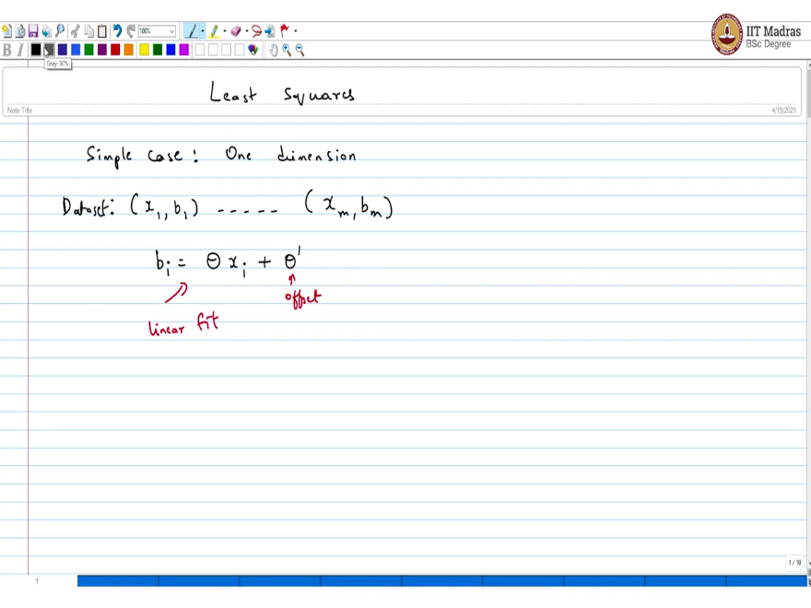
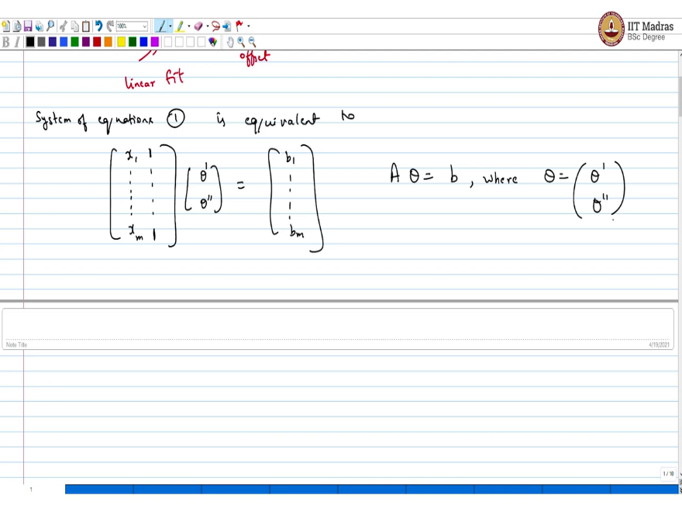
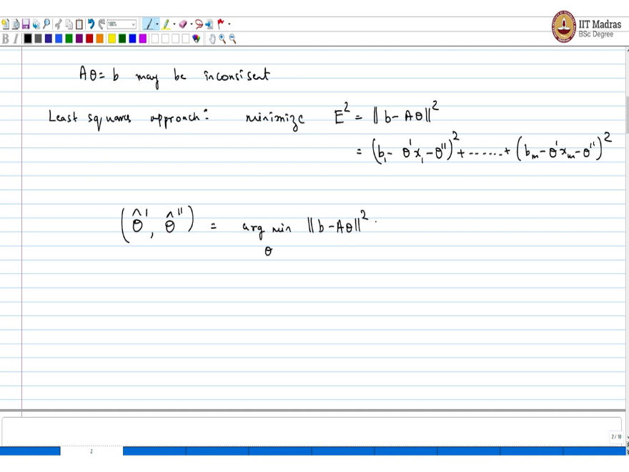
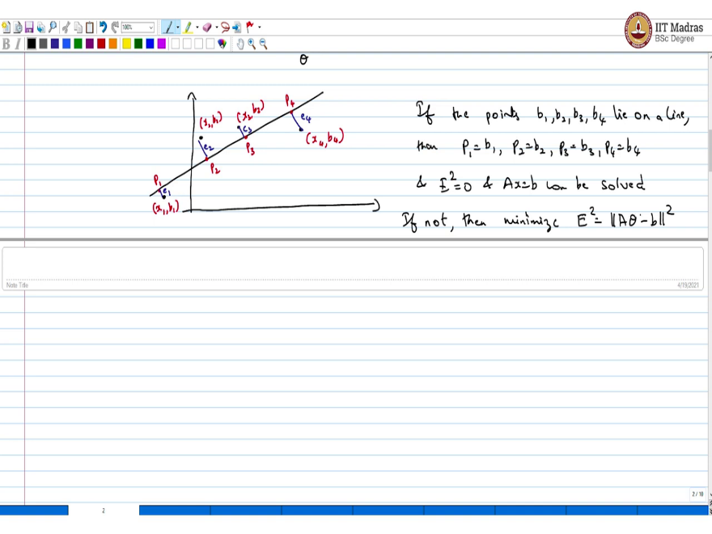
So, we will look at ordinary least squares. The simple case, you have a simple case in one dimension. So, imagine, you have data, imagine you have a data set, say x1, b2, xm, bm. Now, want to find the least squares fit, which is like I want to fit such that beta = θ xi + some θ prime. This is the constant offset. So, this is a linear fit. We want to find such a fit for i = 1 to m, all the data points.
So, what you do is this system of equations, so let me call this 1, system of equations is equivalent to, just put it in a matrix form, what you do is put x1 until xm and 1s 1 times θ prime, θ prime, θ double prime =. Now, this is like A θ = b, where θ = θ prime and θ double rime.
Your job is to find, I mean, A θ = b again may not be solvable, the same story that we have seen before, A θ = b may be inconsistent. So, the least squares approach is to minimize this error, b - A θ square, which is the same as b - θ prime x1 - θ double prime square + . . . b1 - + again until bm, bm - θ prime xm - θ double prime square.
Suppose let us call this θ hat prime, θ hat double prime is the arg min over θ tilde, arg min over θ b - A θ square. So, pictorially what you are doing is, imagine you have points like this. Let me draw the line. So, let us say this is x1 , b1, x2 , b2, x3 , b3, x4 , b4, let us call this P1, P2, P3 and P4. You want to find these points P1, P2, P3, P4 and these distances are the errors E1, E2, E3, E4. You want to find the line that minimizes the sum of the square distance.
If the points b1, b2, b3, b4 already lie on a line, then the projections would be the same as the original points and the square error would be 0 and Ax = b can be solved. Now, if not, then minimize the square error.
(Refer Slide Time: 07:22)
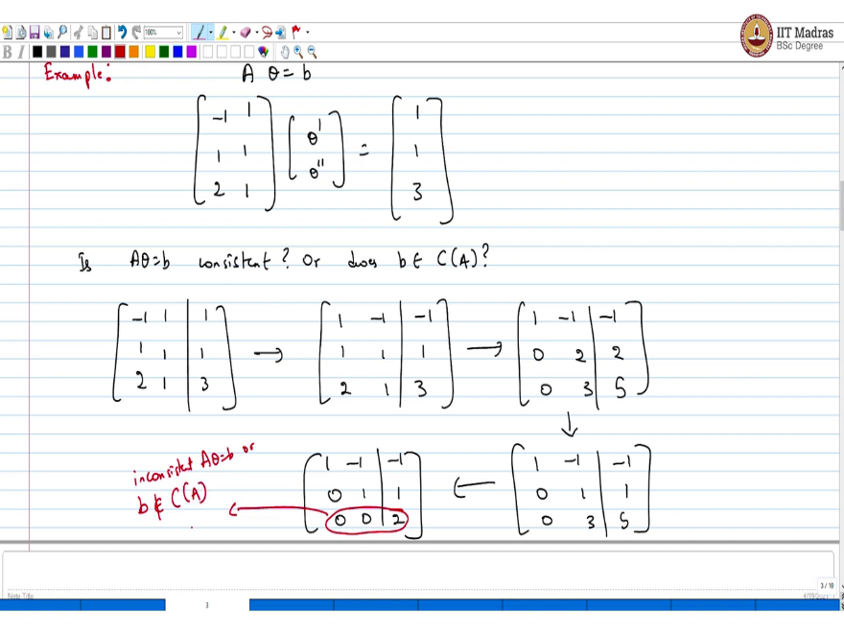
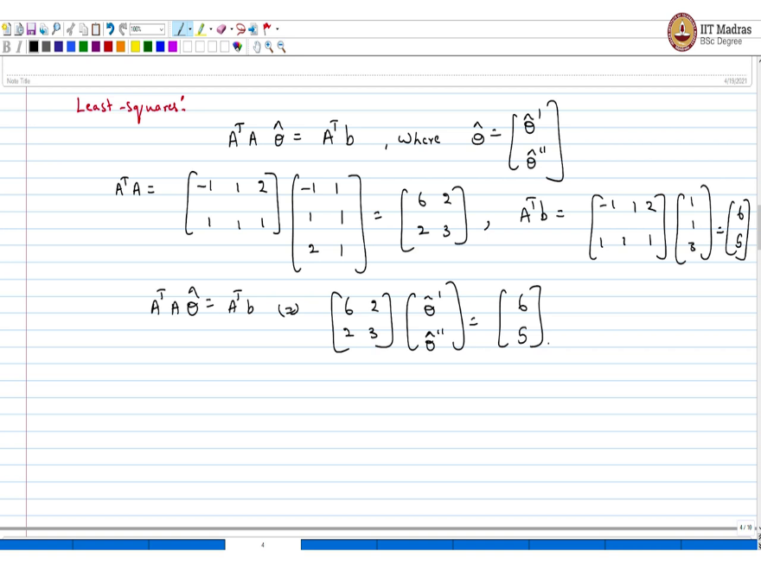
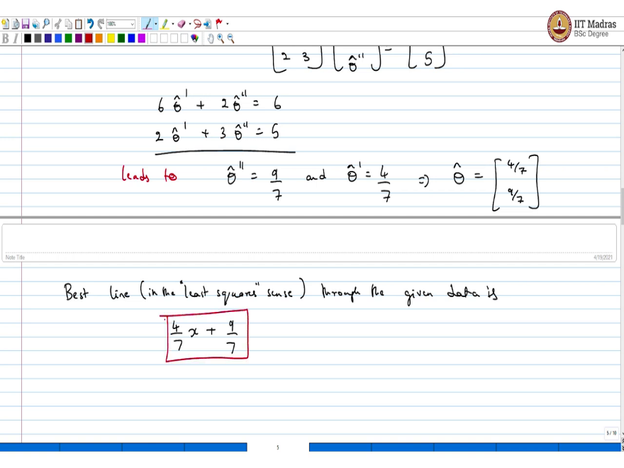
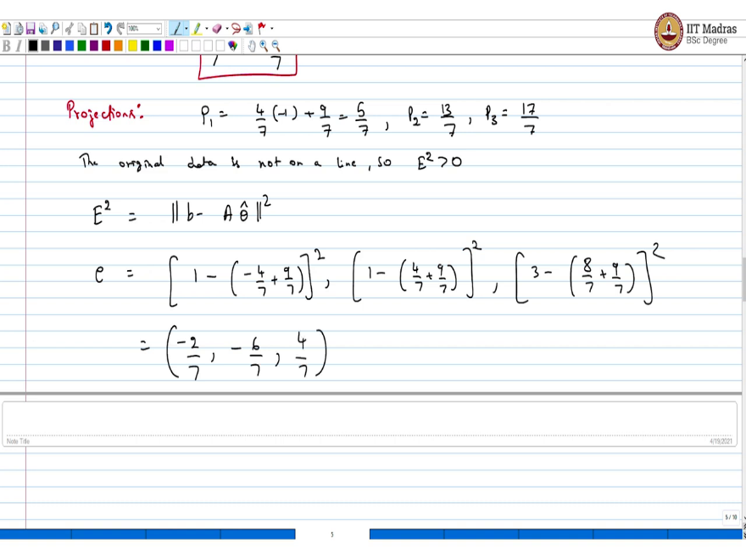
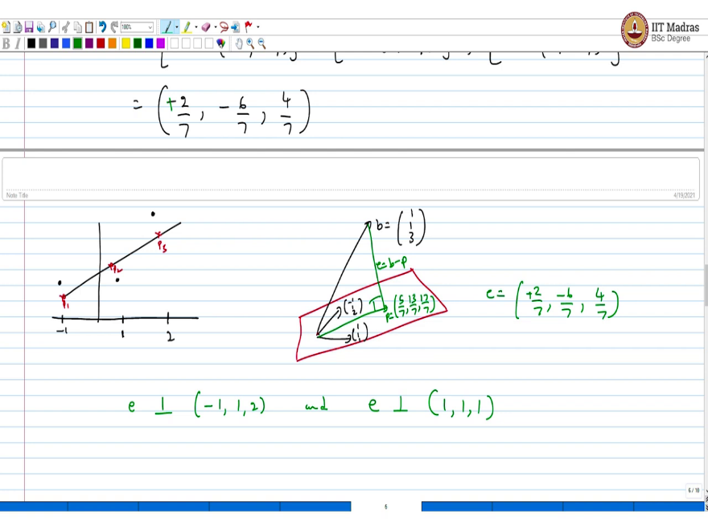
So, look at a quick example to make this idea clear. Imagine let us took a, take a very simple example. Imagine you have the following A θ = b, where A is just 1, 2 at the constant offset, you have θ prime, θ double prime = 1, 1, 3. So, this is your A θ = b. The first thing to check is, is this system solvable. Is A θ = b consistent? Now, how do you do this? You just do Gaussian elimination. So, just throwing - 1, 1, 2, 1, 1, 1 and then 1, 1, 3, or does b belongs to column space of A?
This if you do Gaussian elimination, I am not explaining each step, but I hope it is obvious, Gaussian elimination is covered in an earlier course and it is a fairly basic algorithm for inversion and checking if system of equations is solvable all that. So, I am just reducing it to the echelon form, 0, 2, 2, 0, 3, 5 and this becomes 1, - 1, - 1, 0, 1, 1, 0, 3, 5 and that becomes 1, - 1, - 1, 0, 1, 1 and unfortunately 0, 0, 2. So, this just implies inconsistent A θ = b or b does not belong to column space of A.
So, we can go ahead. So, the point is the first thing to check is given a system is it even consistent? If it is already consistent, there is no point going and solving an alternative equation, where, I mean, the original set of equations is already solvable. Now, in this particular case, unfortunately the data it says that, it has, you have an inconsistent system. So, we will do least squares.
So, for least squares what you need to do is to solve A transpose A θ hat = A transpose b, where θ hat is θ hat prime, θ hat double prime. This is what you need to solve. So, what is, I would encourage you to just pause the video now and work out all of the details of this exam. You are given the recipe. Just please work out all the details on your own, find θ hat prime, θ hat double prime after finding A transpose A and looking at this system of equations.
So, I am just going to give out the solution, but I strongly encourage you pause and do this. So, this is - 1, 1, 2, 1, 1, 1, this is nothing but 6, 2, 2, 3. And you can also check A transpose b = into b 1, 1, 3 = 6 , 5. So, what you have is A transpose A θ hat = A transpose b is the same as 6, 2, 2, 3 to θ hat 1, θ hat double prime = 6 , 5.
This is just a normal high school simultaneous set of equations, which can be solved, which is equal to 6 times θ hat prime + 2 times θ hat double prime = 6, 2 times θ hat prime + 3 times θ hat double prime = 5 and this leads to θ hat prime which is, the first thing that comes out easily is θ hat double prime and the other one comes out to be 4 by 7.
So, we got the θ hat vector which is, so the least square solution is θ hat = 4 by 7, 9 by 7. So, the best line in least squares sense through the given data is this line it is 4 by 7 times x + 9 by 7. This is the best line. Now, recall, I mean, the data, I mean, using this b whatever we got, I mean, the input points, so just go back to the system of equations that you have here. The input points are - 1, 1 and 2 and the output is 1, 1 and 3 and we just figured the best line is this.
So, the projections, what are the projects, the projections are, what is P1 which is projecting the very first point would be 4 by 7 into something + 9 by 7. The very first point is - 1 leads to 5 by 7. The projection of second point, I am not going to give out the full thing, but it is 13 by 7, x is 1 there, and this one is 17 by 7 for x = 2. Now, given this, it is clear that these quantities are not on a line, because you would have recurred the original points. The original set of points, the original data is not on a line, so the square error is going to be greater than 0.
Let us calculate the square error which is equal to b - A θ hat square. This is the minimum of the least squares and this is going to be b is 1, 1 and 3, if you remember and A θ hat we have just figured out, just P1, P2, P3. So, you get 1 -, - 4 by 7 + 9 by 7 square and + 1 - 4 by 7 + 9 by 7 square + 3 - 8 by 7 + 9 by 7 square, sorry, this square is outside. And this whole thing turns out to be - 2 by 7.
Let me calculate the e. I want to write this as e. E is - 2 by 7, because I want to find the projection, - 6 by 7 and 4 by 7 that is your vector e. Now, you can observe. So, the point is, if you look at the normal pitcher here, you have a line, you have - 1, 1 and 2 and you are looking at some point here, some point here and some point here, and then your projections would be here, projections P1, P2, P3.
Now, you can look at this in terms of some space also. And this is spanned by two vectors. This is a plane that you are looking at. And the vector b is somewhere outside, b is 1, 1, 3. And these two are the two columns say this is the very first column which is - 1, 1 and 2, 1, 1, 1. And now e is orthogonal to this.
So, we saw that, let me highlight, somewhere here is P, which is equal to, you can calculate this, 5 by 7, 13 by 7, we just calculated this, 17 by 7 and e is, the orthogonal part is whatever we calculate - 2 by 7, - 6 by 7, not - 2, + 2 by 7, - 6 by 7 and 4 by 7 should be a + and you can see that e is orthogonal to - 1, 1, , 2 and e is also orthogonal to 1, , 1, , 1. So, e is in the orthogonal space. So, that is what I wanted to show here, we have a typo here.
This is just a typo here. This should not be square. So, I am calculating e and there is no square here. So, the point is, this is where the connection is. E is going to be orthogonal to the space. So, e is going to be somewhere above and, so let me write this. This is going to be e and this is P and e = b - P which is equal to this. So that completes the least squares fit. We will look at some more topics related to this very soon. Please go over this, try to solve some examples.
A quick summary before we end this lecture and also this week of the, week three of this course. This, the main, so the main learning from this lecture is that we looked at an example, say a linear system of equations, say A θ = b and the motivation for this linear system of equations was curve fitting, so you are given a bunch of data points and you want to fit the best line through these points that runs through these points. And best is qualified in terms of least squares. So, you want to fit the line that minimizes the sum of squares.
And what we did was we solve this problem using the projected system of equations. And before that, we also saw that these points are not on a line, which is to say that A θ = b is not solvable, b is not in the column space of A. And so we had to do projections, we had to project these points onto a line. And we solved this explicitly through the example and understood the concept of solving least squares. And also, hopefully, one got a good grip of projections through this particular example, curve fitting example.
Moving on, in the next lecture, what we will do is we will generalize this curve fitting example to a multi-dimensional case. The ideas would not be new, it is the same idea. We will just write down the system of equations in a more general vector parameter setting, not just projecting onto a line, but projecting onto a general subspace.
And that would be characterizing the linear regressions or least squares regression. We will understand least squares regression which is the first most simple machine learning method that you can look at. And you can also understand well from a linear algebra viewpoint.

